**Hush the Noise**

I wonder how well you might know some traditional carols; whether you might be able to tell me from which carol certain words come. How about ‘and fit us for heaven’? Or, ‘be born in us today!’? Or ‘Christ the Redeemer is here!’? Or ‘hush the noise’?

This year the Methodist Church is inviting people to ‘Hush the Noise’ and to ‘Join the love song this Christmas.’ (‘Love-song’ is found in the same carol as ‘hush the noise.’) This is not the Methodist Church being a killjoy. Parties, Christmas music in stores, television adverts adding to the hype; all have their place in a British, 21st century observance of Christmas. However, we may (or may not) welcome all of these as they contribute to the ‘noise’ that is around, making Christmas ‘loud.’ What the Methodist Church is seeking to do is to encourage others and ourselves to find some time away from all the noise, so that we can hear something of the message of Christmas and ensure that it is not drowned out.

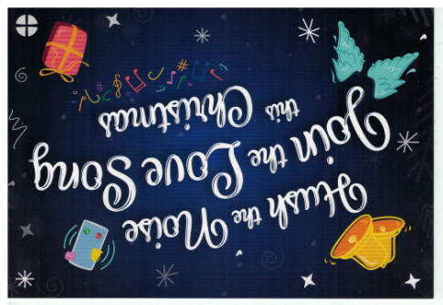What, then, is the ‘love-song’? Well, according to the carol in which it is found, it is a love-song which is sung by angels and about peace:

‘beneath the angel strain have rolled two thousand years of wrong; and man, at war with man, hears not the love-song which they bring. O hush the noise, ye men of strife, and hear the angels sing!

This carol was originally a poem written by the American Minister Edmund Sears in 1849. This was after a war in North America and when there was unrest in Europe. Presumably, a hopeful message about peace was needed (and this theme re-appears elsewhere within the carol – ‘Peace on the earth’, ‘with peaceful wings unfurled,’ ‘The Prince of Peace their King’). This Christmas, where people are at war with each other, the love-song of the angels is being ignored; as rockets, explosions, gun-fire and the cries of anguished people prevent it from being heard. We need the noise to be hushed so that reconciliation can be sought.

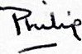The Methodist Church Christmas resources are being released throughout the Advent and Christmas season. There is a recording of Edward Sears’s carol. There is a short advert. There are daily reflections. All are there to encourage us and others to hush the noise and discover what the love-song of the angels may be for us individually this Christmas. It may not be a message about world peace. It could be a gospel song about how God loves you unconditionally with no strings attached. Or it could be a ballad offering you words of comfort. Or it could be an anthem which spurs you to action. So, why not seek to ‘Hush the Noise’, whenever you can, as Christmas approaches, that you may hear the angels’ love-song and join in with it?

[The words from the carols in the opening paragraph come, in order, from ‘Away in a manger’, ‘O little town of Bethlehem’, ‘Silent night, holy night’ and ‘It came upon the midnight clear.’

More resources for ‘Hush the Noise’ can be found at: methodist.org.uk/faith/hush-the-noise]