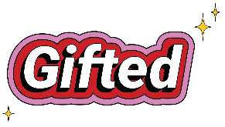

If you travel away from the city, along Ecclesall Road South, you will come to ‘The Prince of Wales’ pub. There is then a series of shops: Ecclesall Fisheries, Bruno Expresso Bar, Banner Cross NHS Pharmacy, Chocolate and Cheer, Cheese and Friends, then another shop, Holistic Healing Sheffield, and Roses the Bakers. What is the name of the shop that is missing? You may know that it is ‘Gifted,’ which co-incidentally, is the title of this year’s Methodist Church Advent and Christmas campaign.
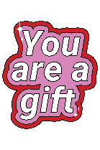

Gifted is a message of good news. Its strap-line is: ‘You are a gift. Made with love.’ It’s meant to remind us how special we are, not because of anything that we may have done or achieved or can give, but simply because we are: ‘Beloved. Created with infinite care. A gift to the world.’
Gifted also has another meaning, which is to do with having a talent or ability or skill. We all have something which we can offer to be used for the good of our families and friends, the communities in which we live or work or take our leisure, or the faith group which we inhabit. This is to do with being the gift which we are to others.
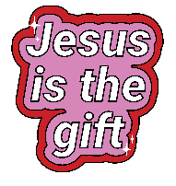
As we travel through Advent to Christmas we will celebrate the coming of Jesus, who is gifted to us and the best gift ever given. He too was made with love and during his ministry gave others, especially those who felt that they had little worth, attention and unconditional love. Jesus comes to show us that we are: ‘Beloved. Created with infinite care. A gift to the world.’
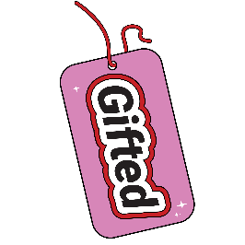
The ‘Gifted’ shop is on Silver Hill (where there used to be a house). It got its name, so the story goes, because a hoard of silver was discovered there in the early 1800s. May it be that real treasure of lasting worth is found through these Gifted resources.
Wishing you a peaceful and joyful Christmas,
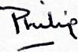
https://www.methodist.org.uk/for-churches/christmasresources/

