**AN EXCURSION IN SCIENCE**

Genetics has always fascinated me since school days when I was first introduced to the experimentation of Gregor Mendel. I became acquainted with DNA, its 3D molecular structure and how it carried genetic information. Later on, I discovered techniques such as genetic mapping and the possibilities of manipulating genes.

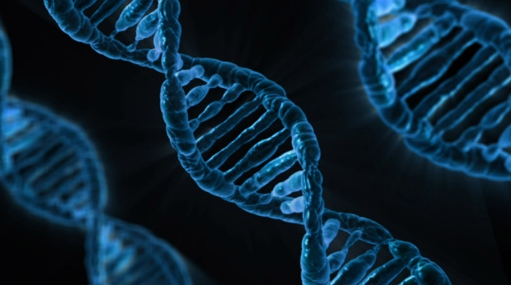Somewhere along the way, I studied the way in which viruses act. Virus particles attach themselves to certain cells and infect them with their own genetic material. This then takes over the machinery of the invaded cells forcing them to make the components of viruses rather than what they normally produce. So, more virus particles are manufactured and the cells are unable to function properly. Obviously, this is detrimental to the human, animal, plant or bacterium concerned.

You may wonder why I am taking this excursion in the field of science, a fair enough thought. It is because we are in the month when the Christian Church will be celebrating Pentecost, when the Holy Spirit came in power to the first disciples of Jesus and because I’ve been reflecting on the work of the Holy Spirit in an individual’s life. We talk of the Holy Spirit coming into a Christian’s life and helping that person to be better than they would be without the Spirit’s presence. It is the Spirit’s place to help an individual produce love, joy, peace, patience, kindness, goodness, faithfulness, gentleness and self-control in their lives (Galatians 5:22-23a). These products of the Spirit’s work are obviously desirable.

We can draw a contrast between the beneficial effect brought about by the Spirit and the negative effect brought about by a virus. However, I want to take this further and to suggest that normally as human beings we are like cells manufacturing products which are not as good as they could be. Our love is often tainted, our patience short-lived, our kindness restricted to a few and our self- control limited. We are not as good at reproducing these qualities and the others as the cell is in making its own products. So, we need help if we are to be more peaceful, gentle, faithful and the like. How can this come about? I suggest the picture of the Holy Spirit ‘invading’ the cells of our lives and then using the machinery that is already there to produce love, joy, peace and other qualities that have been mentioned to a better degree than we can manage alone.

May the fruit of God’s Spirit be seen in our lives.

